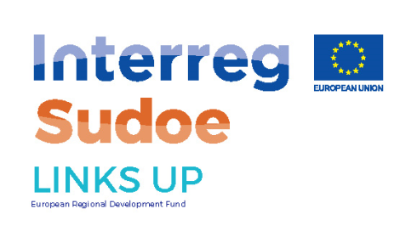

***LINKS’UP CALL FOR PROJECT***

***ACCELERATION & SOFTLANDING PROGRAMS***

***2 actions of the European Projects LINKS UP led and implemented by Castres-Mazamet Technopole & FundacióBIT***

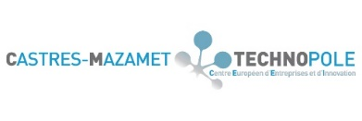

[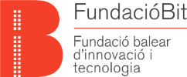](https://www.google.fr/url?sa=i&rct=j&q=&esrc=s&source=images&cd=&cad=rja&uact=8&ved=2ahUKEwixsvr_h7LaAhWBbVAKHU5oDMsQjRx6BAgAEAU&url=https://ebn.eu/project/watify&psig=AOvVaw2-X_IJMk7twEchYWVXICzm&ust=1523530625468300)

**LINKS UP CALL FOR PROJECT 2018**

**For E-Health & E-Tourism companies**

***Of the SUDOE transnational region.***

**APPLICATION FORM**

* **This is the application form of the LINKS UP Acceleration and Softlanding program call for projects.**
* Answering the questionnaire shouldn’t take you more than 15 mn.
* Answer clearly each item **in English**. You can answer briefly with bullet point lists or short sentences as long as is answers the question.
* Read attentively the program and call Guidelines attached.
* The deadline to send your application is May 18th.
* Once completed, send back this application by email and at pdf format to the following email address: dpto-finanzas@fuem.es
* **Please send in addition to the application form:**
* A one pager presentation of your company in English
* A pitch deck presentation (PPT format 10 slides maximum) or an executive summary (4 pages WORD format) with the following information in English
  + - Product / Service description
    - Market
    - Team, skills & partners
    - Activity and financial forecast

1. **COMPANY INFORMATION**

* **Company name**
* **Date and place of incorporation**
* **Industry**

🞎 **E-HEALTH** 🞎 **E-TOURISM**

* **Short description of project/ activity (maximum 500 characters)**
* **Website (if any)**

1. **COMPANY LEADER CONTACT INFORMATION**

* **Last Name and First Name**
* **City – Region -Country**
* **Phone**
* **Email address**
* **Skype (recommended)**
* **Education level / Diploma/ Field**
* **Current Position in the company (title and duration)**
* **Level in written and spoken English (1=beginner, 2=Intermediate, 3=Fluent 4= Native Speaker)**

1. **MATURITY OF YOUR PROJECT**

* **Advanced Business model and plan financing plan?**
* **First client or strong partnership (experimentation/ cobranding/ distributor…)?**
* **First level of revenues or fundraising?**
* **Market or partnerships opportunities in the LINKS UP area (first clients and revenues)?**
* **Team?**

1. **Innovation**

* **Solution provided or developed**
* **Value proposition**

1. **Interest in open innovation activities**

* **Strong interest in developing partnerships and collaborations with corporates?**
* **Identified corporates or programs?**
* **Knowledge of open innovation processes?**

1. **Interest in internationalization**

* **Strong interest in expanding activities to the other countries of the LINKS UP and in dedicating time to find potential opportunities and partners? Please specify your wishes, ideas or identified contacts**
* **Skills and capacity to communicate in professional English? (pitch, negociation, sales, financial, and technical matters, discussions)**

1. **Needs and expectations**

* **What are your needs to go ahead with the development of your company (money, clients, new markets, partners….?**
* **What do you expect from the acceleration and soft-landing programs in terms of support services, training, expertise ? (skills, expertise, topics of support….)**
* **Additional comments**